Scale Model of the Planets
Overview: Students will learn the sizes of the planets and compare them to Earth in a scale model.
Materials:
- White construction paper
- White butcher paper
- Cardboard
- 15 yards of string
- Meter stick
- Index Cards
- Pencil
- Tape/Glue
- Scissors
- Crayons/Colored Pencils/Markers
Activity - Step One:
Create paper scale models of the four inner planets by drawing a circle on the white construction paper according to the radius sizes indicated on the chart below. Color the planets according to the color in the chart.
Planet | Color | Circle Radius
Mercury | grey | 1.9 cm
Venus | yellowish-white | 4.8 cm
Earth | blue, green, white | 5.0 cm
Mars | Red-orange | 2.7 cm

Scale: Earth’s radius of 3,837 miles = 5 cm

Activity - Step Two:
Create paper models of the four outer planets using butcher paper and a meter stick and drawing a circle according to the radius sizes indicated on the chart below. Color the planets according to the color in the chart.
*Note: For Jupiter and Saturn, you will create just a half circle to represent the planets.
Planet | Color | Circle Radius
Jupiter | dark orange & white bands | 56 cm
Saturn | pale yellow | 23.5 cm
Uranus | light blue | 10 cm
Neptune | blue | 9.75 cm

Activity - Step Three:
- Using the cardboard, meter stick, and pencil, you will create a half circle that is the exact same size of Jupiter to use as your display board for this project.
- Start by constructing your scale model of the solar system exactly like it shows in the picture below. Jupiter is first, Saturn is placed next, Uranus and Neptune are on top of Saturn, then the rest of the planets are placed in the following order; Earth, Venus, Mars, and Mercury. (Now you can see the planets in relation to each other in a scale model!)
- Next, you will cut your yarn into 8 pieces, one for each planet.
- Attach pieces of yarn to the completed planets using tape or glue.
- At the ends of the yarn you will attach one index card with the name of the planet on the front.
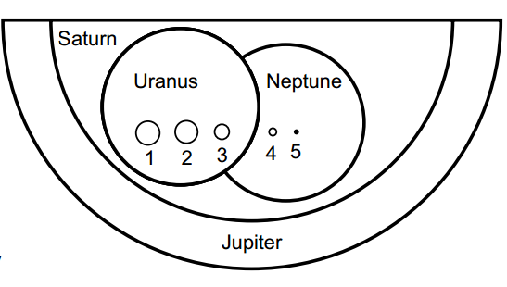
- On the back of the index card you will include the following information about that planet.
  - Atmosphere
  - Size and Composition
  - Temperature
  - Surface features
  - Number of moons
  - 2 interesting facts about the planet
Scale Model of the Planets
Rubric

_____ Accuracy of Planets
All 8 planets are created accurately using both the scaled radius and color of the planet according to the chart given. (30 points)

_____ Layout
The layout of the planets closely resembles the given picture to appropriately show the scale model of the solar system. (10 points)

______ Planet Information
The index cards are properly labeled and contain the name, atmosphere, size and composition, temperature, surface features, number of moons, and at least 2 interesting facts about each planet. (40 points)

_______ Presentation
Handwriting is clear and easy to read. Words are spelled correctly. Model is neat, colored, and displayed properly. (10 points)

______ Team Work
Group worked together as a team. There was proper communication and an equal division of responsibility for each member of the team. (10 points)

________ Total Grade (out of 100)

Comments: ____________________________________________________________________________________________________________________________________________________________________________________________________________________________________________________

